PyCaret & AutoML
Teaching Notes
A from-scratch guide to automated model comparison, grounded in a hand-built comparison loop first. Shows exactly what PyCaret automates, verified against a manual scikit-learn baseline on identical data, and what that automation costs.

Contents

1. The Problem: One Algorithm at a Time Doesn't Scale
This case-study series has covered six-plus algorithms (Logistic Regression, Decision Trees, Random Forest, Gradient Boosting, SVM, Naive Bayes), each tested one at a time, in its own notebook. That's the right way to learn each one deeply. But a real project usually starts with the opposite question: given a new dataset, which of these algorithms should even be tried? Testing each by hand, writing near-identical preprocessing and evaluation code six separate times, doesn't scale, and invites copy-paste inconsistencies between runs.
AutoML tools like PyCaret exist to automate exactly this repetitive part: preprocessing, cross-validating, and ranking many algorithms consistently, in a handful of lines. This note builds the manual version first, on purpose, then checks PyCaret against it, so the automation is verified rather than taken on faith.

2. Step One: Build the Comparison Loop by Hand
Before automating anything, the case study built a genuine comparison loop using plain scikit-learn: six algorithms, the same 10-fold cross-validation strategy, the same five metrics (accuracy, AUC, recall, precision, F1) for each, on loan-default data reused from the Feature Engineering case study.
for each model in {LogReg, DecisionTree, RandomForest, GradientBoosting, SVM, NaiveBayes}:
cross_validate(model, X_train, y_train, cv=10, scoring={5 metrics})
This loop is not a toy, it's the real evaluation discipline used throughout this whole series, just applied to several models back-to-back instead of one. It requires deliberately writing the encoding, scaling, cross-validation, and scoring code once, then trusting it for every model.

3. Step Two: The Same Comparison via PyCaret
PyCaret is a low-code machine learning library built specifically to package this workflow. Its core pattern is two calls:
setup(data=train_df, target="Default")
compare_models()
setup() handles missing values, categorical encoding, and scaling automatically, no manual get_dummies() or StandardScaler needed. compare_models() then cross-validates every algorithm in its library (13, in this case) and returns a ranked leaderboard, sorted by whichever metric you choose.
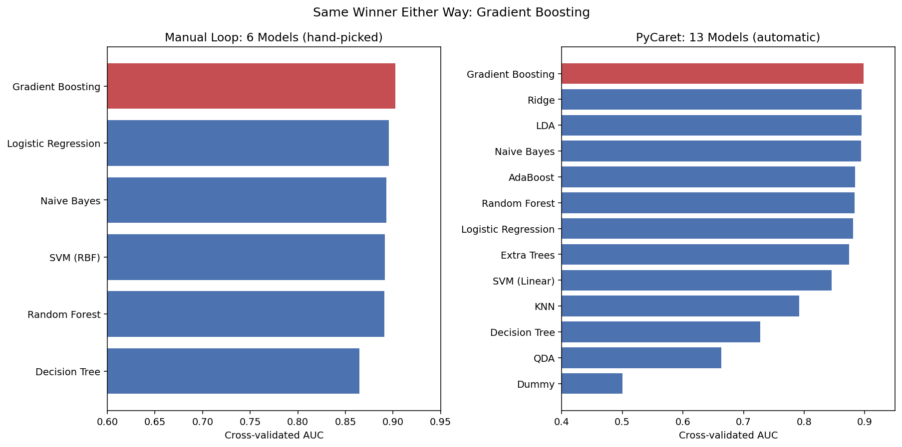
Figure 1. Left: the hand-built loop's 6-model leaderboard. Right: PyCaret's 13-model leaderboard on the exact same training data. Both independently rank Gradient Boosting first (highlighted), out of two completely different implementations of the comparison workflow.
PyCaret tried more than double the algorithms with a fraction of the code, and included several worth knowing that the manual loop skipped entirely (Ridge Classifier, Linear Discriminant Analysis, AdaBoost, Extra Trees), all competitive, all identified automatically. It also includes a Dummy Classifier at the bottom of its leaderboard, an automatic version of the naive baseline used in the Imbalanced Dataset case study, a built-in sanity floor every real model should clear.

4. Does PyCaret Actually Agree? A Direct Check
Agreement on cross-validated training scores is encouraging, but the real test is whether both approaches perform the same way on data neither has seen. The manual loop's winning model (Gradient Boosting) and PyCaret's finalized winning model were both evaluated on the identical held-out test set:
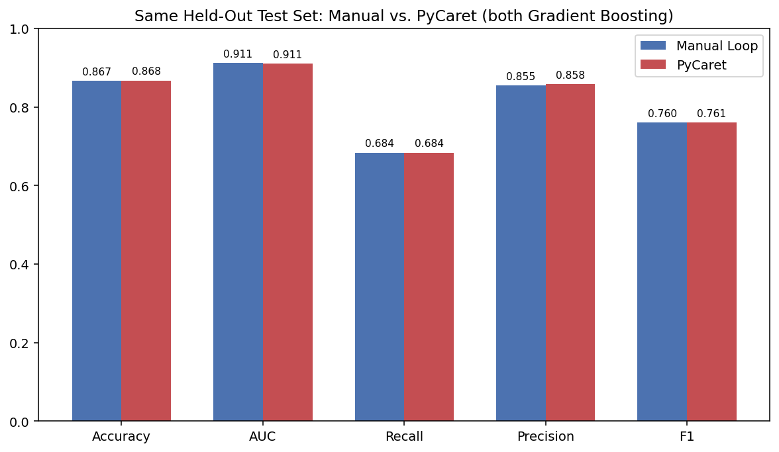
Figure 2. The manual loop and PyCaret, both landing on Gradient Boosting, scored on the exact same held-out test set. Recall matches to four decimal places (0.6838 both); every other metric is within a rounding error.
Metric | Manual Loop | PyCaret
Accuracy | 0.867 | 0.868
AUC | 0.911 | 0.911
Recall | 0.684 | 0.684
Precision | 0.855 | 0.858
F1 | 0.760 | 0.761

This agreement is the real payoff, not a coincidence. PyCaret didn't discover a better hidden model, it independently confirmed the same answer the manual loop already found, through entirely separate preprocessing and cross-validation code. That's a meaningful form of verification in its own right: two independently-built pipelines landing on the same winner is stronger evidence than either pipeline alone.

5. What Else PyCaret Automates

Hyperparameter Tuning, One Line, But Verify It
tune_model() runs an automatic hyperparameter search. On this data, it's worth reporting honestly what actually happened:
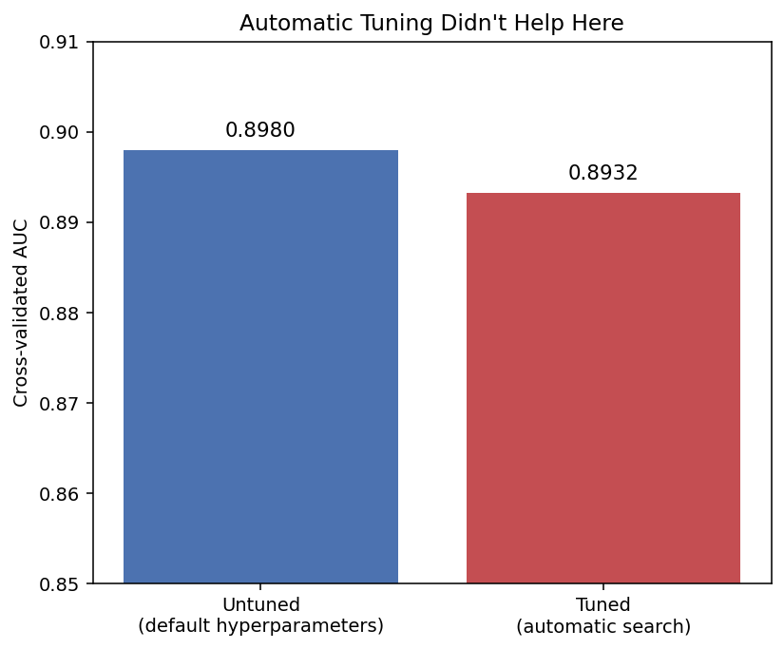
Figure 3. The tuned model's cross-validated AUC (0.893) came in slightly below the untuned default (0.898). Automatic tuning is a search within a budget, not a guarantee of improvement.
The lesson isn't that tuning is broken, it's that low-code convenience doesn't remove the need to check results. tune_model()'s output should always be compared against the untuned baseline, exactly as Figure 3 does, rather than trusted automatically simply because it ran.

Diagnostic Plots, One Line Each
plot_model(best_model, plot="auc") and plot_model(best_model, plot="feature") produce a full ROC curve and a feature-importance chart respectively, each in a single line, work that took several lines of hand-written matplotlib code in every earlier case study in this series.

A Deployable Pipeline, One Call
save_model(final_model, "loan_default_gb_pipeline") saves the encoding, scaling, and fitted model together as a single file. A new, raw application can be scored directly from that file without re-implementing preprocessing by hand, a common source of subtle train/serve mismatches when done manually.

6. The Real Cost: Environment Isolation
PyCaret's convenience isn't free. It pins fairly old versions of core libraries, older than every other notebook in this series depends on, and installing it normally would have downgraded numpy, pandas, and matplotlib globally, risking silently breaking every previously verified notebook in this repository.
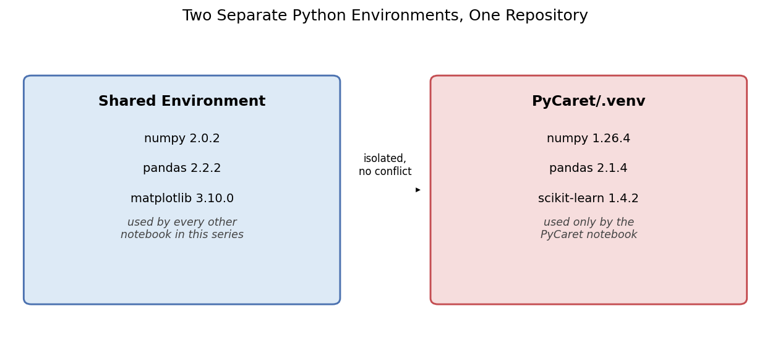
Figure 4. PyCaret runs in its own isolated virtual environment with older, pinned package versions, entirely separate from the shared environment every other notebook uses.
The fix was a dedicated virtual environment just for PyCaret, registered as its own Jupyter kernel. This is a real, practical cost of adopting a heavyweight AutoML library: it should be planned for as part of the decision to use one, not discovered as a surprise mid-project. Teams should expect this kind of isolation whenever adding a large, opinionated dependency to an existing, working project.

7. Strengths, Weaknesses, and When to Use PyCaret

Strengths
- Tries far more algorithms than a team would realistically hand-code, in far less time.
- Automates preprocessing consistently across every model tried, removing a common source of copy-paste bugs in manual comparisons.
- Packages tuning, plotting, and deployment-ready pipeline export behind simple, memorable one-line calls.
- Verified, in this case study, to agree with an independently hand-built comparison, real evidence it isn't a black box producing untrustworthy answers.

Weaknesses
- Heavy, older-pinned dependencies that can conflict with an existing project's environment (Section 6), plan for isolation.
- Automatic tuning is not guaranteed to beat sensible defaults, always verify against an untuned baseline (Section 5).
- Less transparent than hand-written code, when something looks wrong, there's an extra layer to debug through.
- Best used for fast screening across many candidates, not as a substitute for understanding the winning model deeply before deploying it.

Rule of thumb: reach for PyCaret (or a similar AutoML tool) early in a project, for broad, fast model screening across many algorithms at once. Once a short list of promising models is identified, drop back to plain scikit-learn, as in every other notebook in this series, for full control over preprocessing, tuning, and the deep understanding needed before a model goes into production.

8. Summary Cheat Sheet
- A manual model-comparison loop is straightforward to build (loop over models, cross-validate, track metrics), but repetitive and easy to get subtly inconsistent across models.
- PyCaret's setup() + compare_models() automates that same workflow, and tried more than double the algorithms in this case study, in far less code.
- The real test of an AutoML tool is agreement with an independent check, verified here: manual loop and PyCaret landed on the same winning model, with test-set metrics matching to within a rounding error.
- Automatic hyperparameter tuning is not automatically better than defaults, always compare tuned vs. untuned before trusting either.
- One-line diagnostic plots and one-line deployable pipeline export are genuine time savers for the workflow, not just the model search itself.
- Heavyweight AutoML libraries can bring real dependency conflicts, plan for environment isolation as part of the decision to adopt one, not as an afterthought.
- Use AutoML tools for fast, broad screening, then return to hand-written code for deep understanding and control of whatever model is ultimately deployed.

